**FIN810 2019 Final Exam Type B**

**Cohort: Silcon Valley**

**Name: ______________________________**

**Date: _______________________________**

**Instruction:**

* Please keep 5-decimal places for your answers.
* Email me your work (WORD, EXCEL and SAS studio work): [xz4@stmarys-ca.edu](mailto:xz4@stmarys-ca.edu)
* For SAS questions, please paste the complete and relevant code on the WORD file.
* For SAS questions:
  + One question, one SAS program
  + log out and log in your SAS studio
  + run the complete code, under the results tab, find the envelope item (send email)

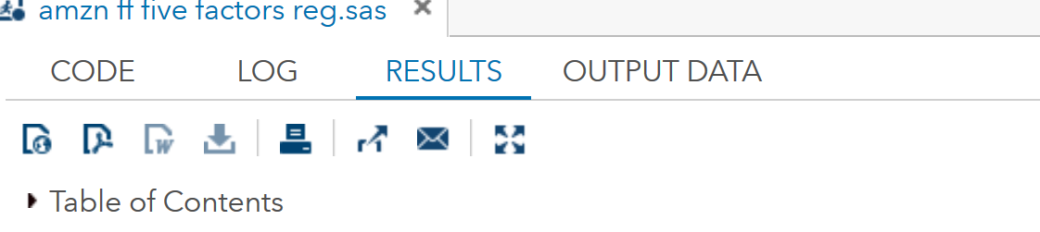

* + Check Code, Log, HTML, Summary. Email to [xz4@stmarys-ca.edu](mailto:xz4@stmarys-ca.edu); CC yourself; Subject: Cohort, Student Name, Question #.

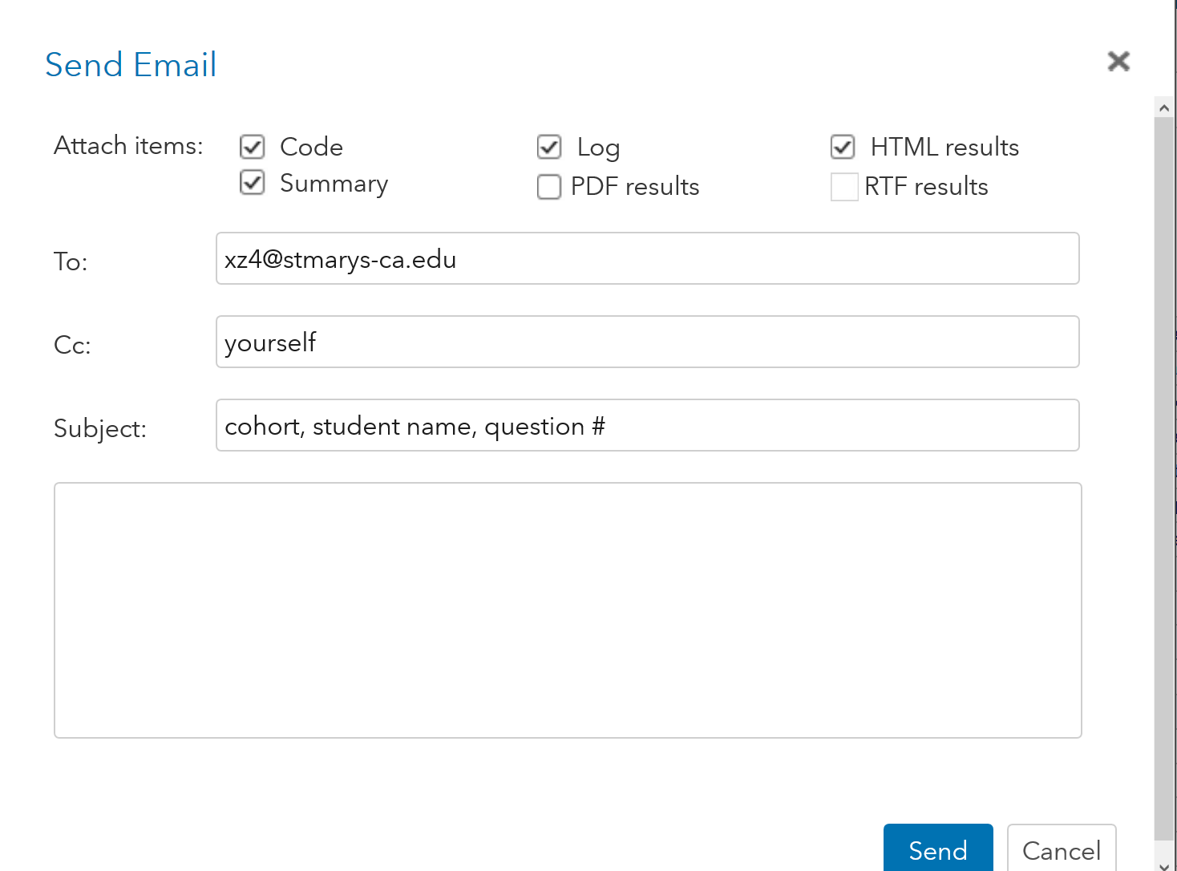

.

**Question One: Asset pricing model: Fama French model (10 points)**

The regression for Fama-French 3-Factor model is as follows.



Use the daily stock return data of XYZ company from 1995 to 2019/4, the regression output is in the following table:

|  |  |
| --- | --- |
|  | XYZ |
| Intercept | 0.00099928 |
| p value of Intercept | 0.1989 |
| Coefficient of X1 | 0.80302 |
| p value of X 1 | < 0.0001 |
| Coefficient of X2 | -0.26920 |
| p value of X2 | 0.0882 |
| Coefficient of X3 | -0.53821 |
| p value of X3 | 0.0181 |

1. At the significance level of 10%, which statement is correct?
2. The stock is predominantly a growth stock.
3. The stock is predominantly a large-cap stock.
4. All of the above.
5. None of the above.
6. If the Fama French 3 Factors are reported as follows:   
     
   Rm-Rf: 10.40% annual  
   SMB: -6.48% annual  
   HML: -14.46% annual

Rf: 2% annual

What is the predicted annual return of the XYZ stock_______________________.

**Question Two: Use Excel to Answer Portfolio Optimization (short is allowed). 20 points.**

Go to SMCMBA, Course Documents, Final Exam, and download the excel file of “LMT_FB_Portfolio”.

The Excel has the weekly stock returns of Lockheed Martin Corporation (LMT) and Facebook from January 15 2015 to June 22 2017.

On June 22, 2017, the quoted U.S. 30-day T bill rate was “0.8”, and assume one year has 52 weeks.

1. Find the mean and standard deviation of the two stocks’ weekly returns.
2. Find the correlation of the two stocks’ weekly returns.
3. Portfolio A has two assets of LMT and FB.
4. If shorts are allowed. If the target weekly return is 0.005 (or 0.5%), what is the optimized portfolio that has the lowest risk (measured by portfolio’s standard deviation)?

LMT Weight:

FB Weight:

Portfolio STD:

Portfolio Return:

1. If shorts are not allowed. Choose a target weekly return:_______ what is the optimized portfolio that has the lowest risk (measured by portfolio’s standard deviation)?

LMT Weight:

FB Weight:

Portfolio STD:

Portfolio Return:

1. What is the optimized portfolio that has the highest Sharpe Ratio?

LMT Weight:

FB Weight:

Sharpe Ratio:

Portfolio STD:

Portfolio return:

1. What is the optimized portfolio that has the lowest risk?

LMT Weight:

FB Weight:

Portfolio STD:

Portfolio return:

1. If shorts are allowed. Choose your target weekly returns and draw the curve of min-variance portfolio.

**Question Three: Use Excel. Cumulative Abnormal Returns: Earnings announcement. 30 points.**

Background: Alphabet’s earnings call on October 22, 2015: Alphabet reported earnings of $7.35 per share adjusted for expenses, topping the Thomson Reuters survey predicting earnings of $7.21 per share. FYI, the news of earnings announcement is as follows.

<http://www.latimes.com/business/technology/la-fi-tn-google-earnings-20151022-story.html>

Go to SMCMBA, Course Documents, Final Exam, and download the file of “GoogleMKTRF20142015”. It has the daily stock returns (RET) of Google, the daily market risk premium (mkt-rf) and the daily 30-day T-bill rates (RF) in 2014 and 2015.

For example, the first observation in the file is as follows:

|  |  |  |  |
| --- | --- | --- | --- |
| Date | Google_RET | Mkt-rf | RF |
| 20140102 | -0.006772 | -0.008755 | 0 |

On Jan 2, 2014, Alphabet’s stock return (Google_RET) was -0.006772 or -0.6772%; the daily market risk premium (Mkt-rf) was -0.008755 or 0.876%; and the daily 30-day T-bill rate was 0 or 0%.

Define T=0 for October 22, 2015.

1) Use the estimation window of (-300, -46) to estimate Google’s CAPM.

|  |  |  |  |  |
| --- | --- | --- | --- | --- |
|  | *Coefficients* | *Standard Error* | *t Stat* | *P-value* |
| Intercept |
| X Variable 1 |

2) Find the Cumulative Abnormal Returns as follows

|  |  |
| --- | --- |
| CAR | Google |
| CAR(-1,0) |  |
| CAR(-3,3) |  |
| CAR (-1, 5) |  |
| CAR(-30,-2) |  |
| CAR (-3,1) |  |

**Question Four: Use SAS. Return anomalies of Fama French 3 factors. 20 points.**

Background:

<http://www.investopedia.com/terms/s/sell-in-may-and-go-away.asp>

“Sell in May and go away”: is a well-known trading adage that warns investors to sell their stock holdings in May to avoid a seasonal decline in [equity](http://www.investopedia.com/terms/e/equity.asp) markets. The sell-in-May-and-go-away strategy is where an investor sells his stock holdings in May and gets back into the [equity market](http://www.investopedia.com/terms/e/equitymarket.asp) in November, thereby avoiding the typically volatile May-October period.

Study Objective: Use Fama French 3 factor weekly data from 2010 to 2018, please test the mean difference of daily returns for the two periods: May-October v.s. November -April, at the 10% significance level.

Fama French data:

<https://mba.tuck.dartmouth.edu/pages/faculty/ken.french/data_library.html>

1. Report the statistics

|  |  |  |
| --- | --- | --- |
|  | Market risk premium in May-Oct | Market risk premium in Nov- Apr. |
| Mean |  |  |
| StdDev |  |  |
| N |  |  |

1. State the hypothesis testing for HML (you can choose one factor from Market risk premium, SMB and HML).
2. Results

|  |  |  |  |
| --- | --- | --- | --- |
|  | Market risk premium | SMB | HML |
| Equality of variance (Yes or no?) |  |  |  |
| Mean difference (returns in Nov-Apr, vs returns in May-Oct. |  |  |  |
| p-value of mean difference |  |  |  |
| Mean difference significant at 10% (Yes or no?) |  |  |  |
| Statistical decision |  |  |  |

1. Open questions: with this analysis, do you find the supporting evidence of different returns between the two periods of May-October vs November-April? Discuss the limitation of this analysis. (Less than 50 words).
2. Complete and relevant SAS Code:

**Question Five: Use SAS and CRSP. Return anomalies (mean comparison). 20 points.**

Backgroud: People often thought that high tech companies outperform the market benchmark. The study is to test whether the returns of tech companies are different from the market benchmark (S&P 500 returns).

Use CRSP data for the years of 2016, design the following portfolio, and compare its returns with the market benchmark (S&P 500).

A portfolio of selected high tech industry: Computers & comp. equipment. SIC codes are 3570-3573 3575 3576 3577.

The portfolio return is a capitalization-weighted average of the stocks. For example, if the portfolio has two stocks, A and B. On the date of 1//2/2016:

|  |  |  |  |  |  |
| --- | --- | --- | --- | --- | --- |
|  | Return | Stock price | shares outstanding | Calculated Market value (market cap) | Calculated Weight |
| Stock A | 0.01 | $10 | 100 | =$10*100=$1000 | =1000/(1000+4000)=0.2 |
| Stock B | 0.03 | $20 | 200 | =$20*200=$4000 | =4000/(1000+4000)=0.8 |

then the portfolio return on 1/2/2016 is

=stock A’s return* stock A’s weight + stock B’s return* stock B’s weight

=0.01*0.2+0.03*0.8=0.026

Definition of CRSP variables

* SICCD: company’s Standard Industrial Classification (SIC) Code
* PRC: stock price
* RET: stock return
* SHROUT: shares outstanding
* SPRTRN: S&P500 return

Study objective: Test the mean difference of daily returns for your portfolio vs S&P500, at the 10% significance level.

1. Report the statistics

|  |  |  |
| --- | --- | --- |
|  | Your portfolio | S&P500 |
| Mean |  |  |
| StdDev |  |  |
| N |  |  |

1. State the hypothesis testing (two sides)
2. Results

|  |  |
| --- | --- |
|  | Return difference |
| Equality of variance (Yes or no?) |  |
| Mean difference (returns for your portfolio, vs. S&P500 returns) |  |
| p-value of mean difference |  |
| Mean difference significant at 10% (Yes or no?) |  |
| Statistical decision |  |

1. Open questions: Discuss the limitation of this analysis. (Less than 50 words).
2. Complete and relevant SAS Code: